Responsibilities and tasks:
- Emails to developers and managers about compilation/unit test failures
- SonarQube
  - Testing memory allocation so that analysis is successful
  - Changes to build.xml for external file with list of extensions to analyze
    - Wrote Java program to compile a list of extensions from corfaxprolint.tab, later this program was not used, and Luke wrote a new one that would get the extensions from .inc files from .pct folder
  - Loading past revisions of development branch (aligned with releases) into SonarQube for analysis
  - Adding new coding rules to Sonar OpenEdge plugin
  - Small configuration changes like leak period
- Configure Jenkins job for CI build
- PCT
  - Testing on how PCT handles class compilation when r-code is saved in the same folder
  - Created new parameter which will save class r-code the same way as .p files, rather than in the root, if the package name is not given: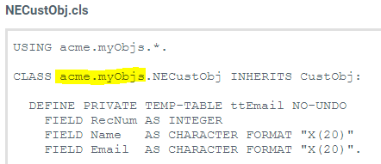
  - Made change to BackgroundWorker class to fix exception that occurred on Jenkins build with multi-threading on
Tools: Just the ones used as above and some form of Eclipse for Java editing, occasionally the Linux terminal
Sites:
PCT: https://github.com/Riverside-Software/pct
SonarQube docs: https://docs.sonarqube.org/display/SONARQUBE67

